**Term Project by Uchechukwu Patrick**

**Site Purpose**

Enugu chamber of commerce is a non-profit making organization of business professionals who have joined the organization to promote civic, commercial, and industrial progress in Enugu state and environs also to promote foreign trade to achieve its expansion; to diversify domestic and foreign markets; to provide its members with opportunities to increase trade and/or cultural relations with other inland provinces and other countries, To be a non-partisan association. To be a major factor in promoting and enhancing the social and economic climate, in which we all live and work.

**Target Audience**

**Who:** Business Enthusiasts, entrepreneurs, students, educators, farmers, agricultural business, event business, engineers, different industries and much more.

**Age:** 18 to 70 years

Technology: Using up to date technologies which provides the best internal and international commerce studies and information.

Income: Income levels will typically be between 0 - 10 billion naira annually.

**Motivation:** To promote the cause of business and economic development through the highest business ethics and standard of practice as well as protect the business environment through public policy advocacy.

**Site Map**

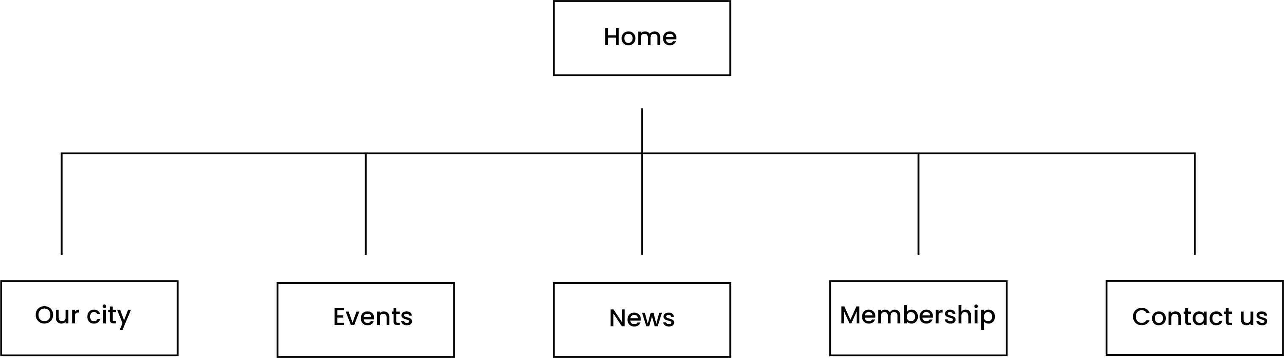

**Color Scheme**



**Typography**

The font to be used in poppins. Geometric sans serif typefaces have been a popular design tool ever since these actors took to the world’s stage. Poppins is one of the new comers to this long tradition.

**Wireframes**

